Application for TGNPDCL
Objective: Build an application using Python program for TGNPDCL, to generate the
bill based on energy consumption and type of customer with the help of AI tools.
Build a python application as per below instructions
• Read all the required data like PU,CU and Type of customer
• Calculate bill amount based on number of units consumed, type of customer
and other charges
• Finally print the values of EC(Energy Charges),FC(Fixed
Charges),CC(Customer Char-ges),ED(Electricity Duty Charges),bill as per
expected output
Requirements:
• VS Code with Github Copilot and/or Google Colab with Gemini
• Students should bring power bill from their home
Deliverables:
• Print energy bill for given inputs and verify with bill taken by s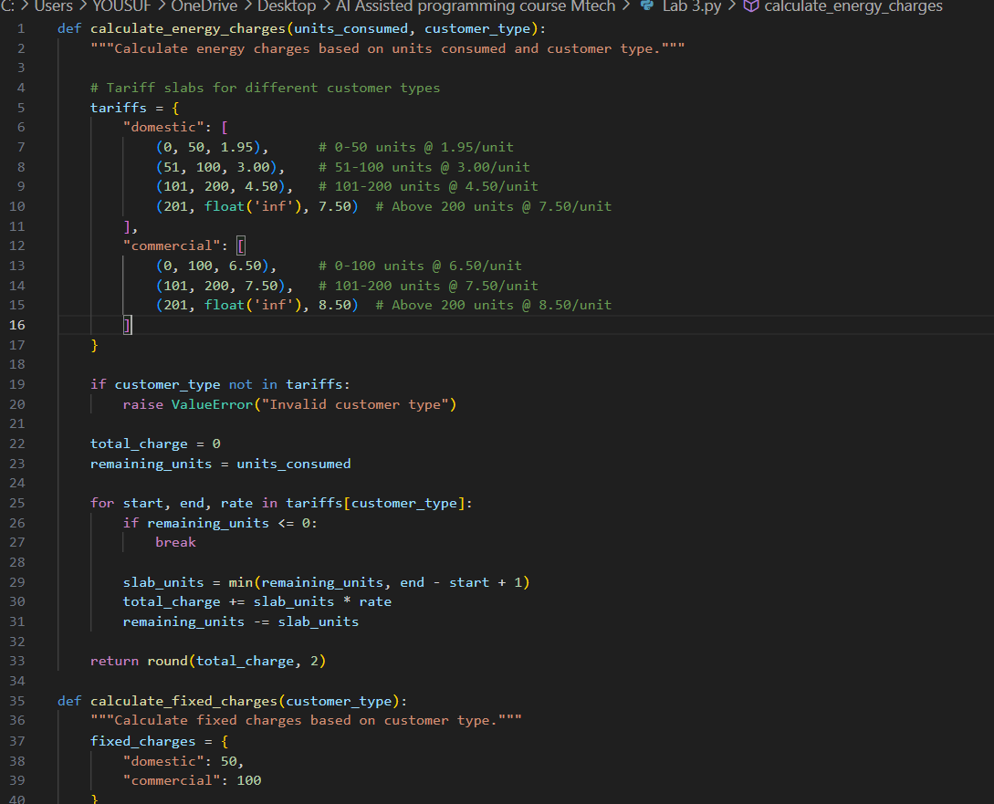 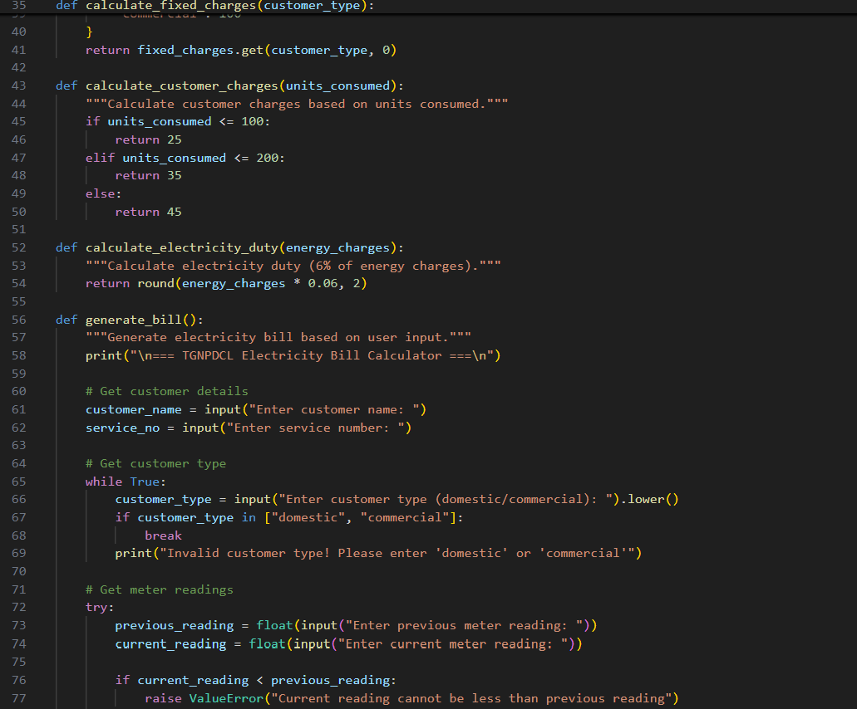
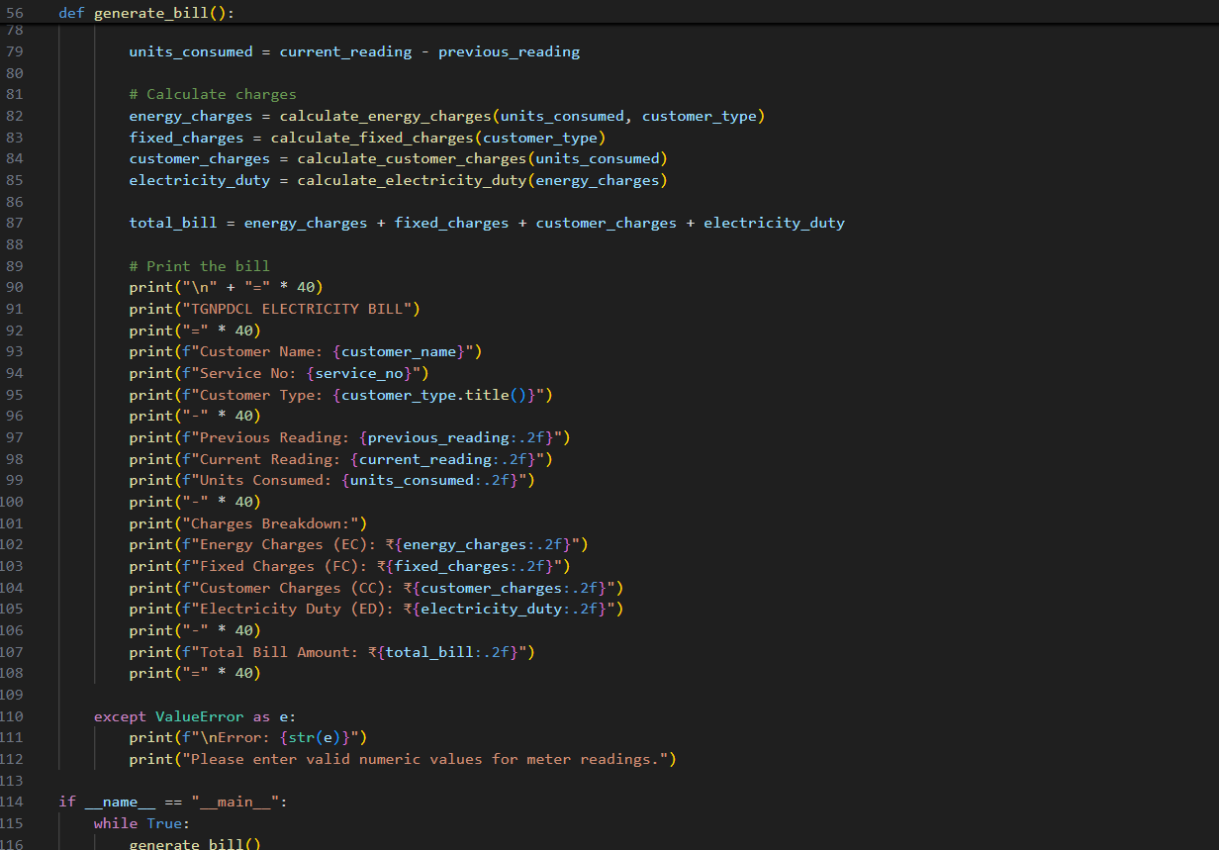
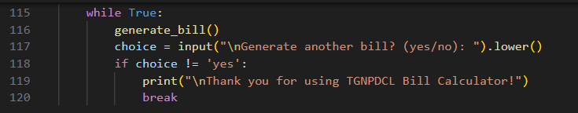

Output:
